

WEBINAR AGENDA
In Her Defense, Session Two:
Beyond Binary, Affirming Advocacy for Transgender Clients

a. Date: September 16, 2026

b. Duration: 60 minutes @ 1:00-2:00 PM EST

c. CLE: NO CLE

d. Title: Beyond Binary, Affirming Advocacy for Transgender Clients

e. Description:
Effective representation for transgender clients requires an understanding of the unique legal, practical, and human challenges they may face throughout the federal criminal process. This webinar will provide strategies for advocating for transgender clients at every stage of the case.

The program will explore how gender identity may inform client communication, trial strategy, mitigation and sentencing advocacy, and representation of clients in pretrial detention and Bureau of Prisons custody. Presenters will discuss common issues involving housing, safety, medical care, and protecting client’s rights while navigating the federal criminal legal system.

Although challenges facing transgender clients are distinct from the challenges faced by cis-gender women we have included this program as part of the In Her Defense Series because many of these challenges are overlapping and deserve equal consideration when presenting a defense.

f. Materials: PowerPoint
g. Presenters: Rachel Eaton, Trial Attorney, Federal Defenders of San Diego, Inc. and Jack Alcantara, Assistant Chief Investigator, Federal Defenders of San Diego, Inc.

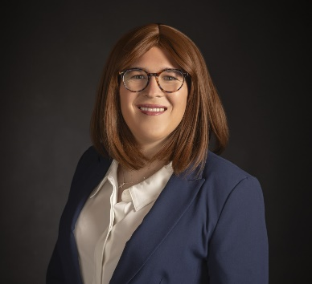
Rachel A. Eaton – Rachel Eaton is a trial attorney at Federal Defenders of San Diego, Inc. She represents clients charged with federal offenses in district court and before the Ninth Circuit Court of Appeals. Before joining FDSDI in 2020, Rachel served as a law clerk for the Honorable John B. Owens on the Ninth Circuit Court of Appeals. Rachel earned her B.A. in Political Science at the University of Texas at Dallas and earned her J.D. with high honors from the University of Chicago Law School, where she served as managing editor of the University of Chicago Law Review. Since joining Federal Defenders, Rachel has become deeply involved in the local legal community, and she currently serves as a Lawyer Representative of the Southern District of California and as Vice President of Professional Advancement on the San Diego Federal Bar Association’s Board of Directors. As a Lawyer Representative, Rachel organized and moderated a panel on issues facing transgender and nonbinary parties in federal court, which was presented at the 2026 District Conference for the Southern District of California. Rachel is a transgender woman and publicly came out as trans in 2025.
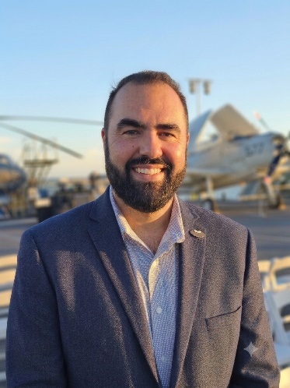
Jack Alcantara is the Assistant Chief Investigator at Federal Defenders of San Diego, Inc., with more than 20 years of experience in criminal defense investigations. He works with attorneys on complex federal cases, conducting field investigations, reviewing evidence, and interviewing witnesses across the U.S. and Mexico. Jack also supervises undergraduate investigative interns, helping train the next generation of defense investigators. He holds a Juris Doctorate from Monterey College of Law and is a licensed California attorney and private investigator.
Jack’s commitment to trauma-aware, identity-affirming advocacy is grounded in his work on a capital case involving a young Latina veteran who began her gender transition during litigation. Supporting her through that process required the defense team to adapt communication practices, and understand the medical, emotional and safety challenges she faced in custody. This experience informs Jack’s current work developing national training on representing transgender clients in federal custody with dignity, respect, and cultural competence.

